23rd April 2014

Gomala Devi D/O Rajasferow

No 73 Jalan 3 KampungTersusun,

Batu 3 ½ Jalan Kota Bharu,

31600 Gopeng Perak.

To: **MISS SYIKIN**

Dear Sir/Madam,

**APPICATION FOR CUSTOMER SERVICE POSITION**

I was very interested to apply for above mentioned hope to be considered for this post. My full particulars are show on my enclosed resume.

I shall be pleased to provide any further information you may need and hope may be given the opportunity of an interview. Do not hesitate to call me at 016-5404430 at any time as your convenience.

Thank you.

Yours faithfully,

Gomala Devi D/O Rajasferow

Encs

**RESUME**

**GOMALA DEVI D/O RAJASFEROW**

**Bachelor in Healthcare Management**

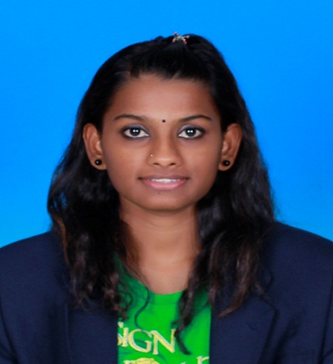

Address: No 73 Jalan 3 Kampung Tersusun

Batu 3 ½ Jalan Kota Bharu

31600 Gopeng Perak.

Telephone no: 016-5404430

E-mail Address: rgomala@yahoo.com

**PERSONAL PARTICULARS**

Date of birth : 30 December 1989 Sex : Female

Marital Status: Single Nationality: Malaysian

EDUCATION

Level : Degree

Institution : Asia Metropolitan University

Field of Study : Degree in Healthcare

Sponsorship : PerbadananTabungPendidikanTinggiNasional (PTPTN)

Grade : Latest GPA = 3.00 CGPA = 3.43

Graduation : January 2013

Level : Diploma

Institution : Masterskill University College of Health Science

Field of Study : Diploma in Healthcare

Sponsorship : PerbadananTabungPendidikanTinggiNasional (PTPTN)

Grade : Latest GPA = 3.00 CGPA = 3.10

Graduation : October 2010

Level : SijilPelajaran Malaysia (SPM)

Institution : SekolahMenengahKebangsaanIdris Shah Gopeng Perak

Grade : 3C,5D

Graduation : December 2006

**RESEARCH PROJECT**

**Title:** Research on “ Level of HIV/AIDS Knowledge among male and female students in SekolahMenengahKebangsaanIdris Shah Gopeng Perak.

Panel: Supervisor

Miss Yasotha (Lecture)

**WORKING EXPERIENCE**

Organization : Nasam Perak

Period : 3 months (Practical)

Task : Telecommunication, patient data entry

Organization : Polyclinic Wong

Period : 6 months (Pratical)

Task : Telecommunicaton, patient data entry, labelling and packaging

Drugs, drugs prescription

Organization : Papa John Pizza (Berjaya company)

Period : 5 months

Task : Cashier, Telemarketing, Manage stock in and out

(LIFO and FIFO) and service

Organization : Bangunan UMNO

Period : 5 months

Task : **(BILIK GERAKAN)** Telecommunication, Data entry

Organization : SRG Asia Pacific (U Mobile)

Period : 9 months (On Going)

Task : Customer relationship and service

**COMPUTER SKILL**

Operating System: Windows 95, Windows 98, Windows XP, Windows Vista, Windows 7, SPSS

(Statistical Package Social Science version 16.0)

Microsoft Office: Good understanding of Microsoft Words, Microsoft Power Point, Microsoft

Excel

**STRENGHT**

* High willingness to explore, accept changes and new challenges, self-motivate, Good team player, fast learner,flexible,hard worker, problem solver
* Full clean Malaysia car license
* I willing to work far from my country.

**LANGUAGES**

* Languages : Fluent in spoken Chinese, English, Malay,Tamil
* Written : Fluent in written English, Malay

Expected salary: $ 1800-$2200

Notice period: 1 months

**REFERENCES**

The following persons have agreed to provide any additional information regarding my qualifications and character:

Miss UmasenanTanikasalam

Senior Lecture

Asian Metropolitan University

G-8 JalanKemacahaya,Batu 9,

43200, Cheras Selangor

03-90805888

Mrs Abbas

Team Leader in SRG Asia Pacific ( U Mobile)

B-10-4 Megan Avenue 1,189 Jalan Tun Razak 50400 Kuala Lumpur

0182008786

MissYasotha

Senior Lecture

Asian Metropolitan University

G-8 JalanKemacahaya,Batu 9,

43200, Cheras Selangor

03-90805888